**Bayes Rule**

prior probability * test evidence => posterior probability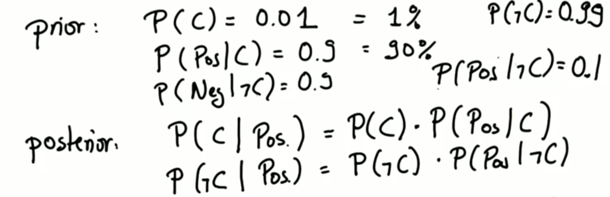

---

Bayer rule diagram

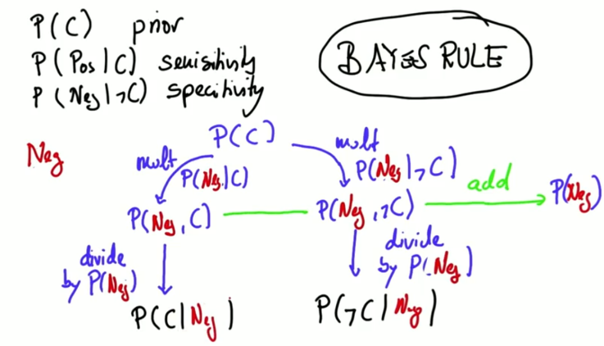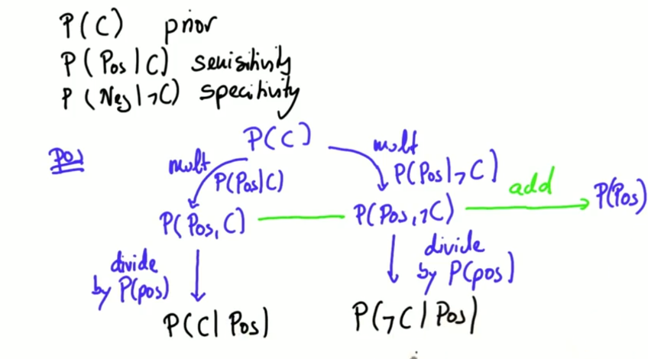Positive Negative

**Summary of Bayer rule**

There is 3 terms that Bayer’s rule relies on:

Prior probability:

It is the probability of an event before performing the test.

Posterior probability:

It is the updated version of prior probability after applying Bayer’s rule.

And the last thing is test evidence.

